G. Surendhra kumar(192524310)

SET 1: Monthly Sales Data
Task 1: Create a Line Chart (Monthly Sales)
Procedure
- Open Tableau Desktop.
- Click Connect → Microsoft Excel/Text File and load the Monthly Sales dataset.
- Go to Sheet 1.
- Drag Month to the Columns shelf.
- Drag Sales to the Rows shelf.
- Tableau automatically creates a Line Chart.
- Click Show Me → Line Chart (if needed).
- Edit the title as Monthly Sales Trend.
- Rename the X-axis as Month.
- Rename the Y-axis as Sales ($).

Task 2: Create a Bar Chart (Top-Selling Products)
Procedure
- Open a New Worksheet.
- Drag Product Name to Columns.
- Drag Sales to Rows.
- Choose Bar Chart from Show Me.
- Sort the bars in descending order.
- Add Sales to Label on the Marks Card.
- Edit the title as Top Selling Products.
- Label both axes properly.

Task 3: Scatter Plot (Advertising Budget vs Sales)
Procedure
- Open a new worksheet.
- Drag Advertising Budget to Columns.
- Drag Sales to Rows.
- Select Scatter Plot from Show Me.
- Drag Month to Label or Detail.
- Format the chart title as Advertising Budget vs Monthly Sales.
Insight
- Points moving upward indicate that higher advertising budgets are associated with higher sales.
- Closely grouped points suggest a strong positive relationship.

Task 4: Interactive Dashboard
Procedure
- Click New Dashboard.
- Drag the Line Chart onto the dashboard.
- Drag the Bar Chart beside it.
- Click the chart menu → Use as Filter.
- Add dashboard title Monthly Sales Dashboard.
- Save the workbook.

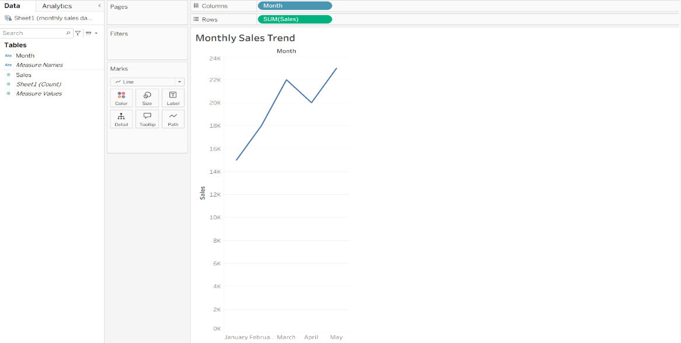

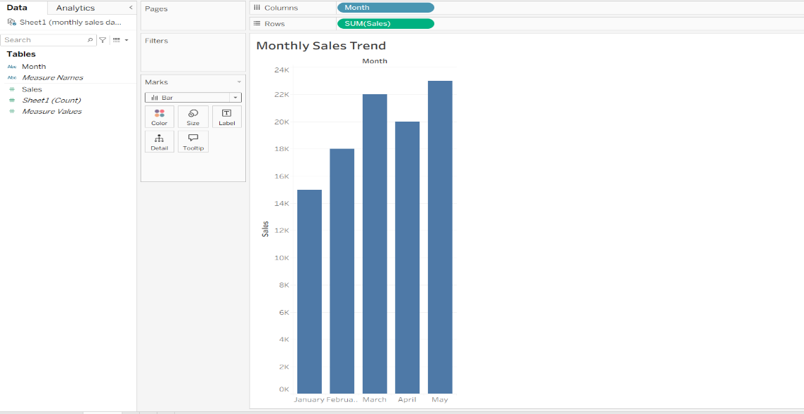

SET 2: Customer Feedback Analysis
Task 1: Histogram (Customer Age)
Procedure
- Load the Customer Satisfaction dataset.
- Open a new worksheet.
- Right-click Age → Create → Bins.
- Accept the default bin size.
- Drag Age (bin) to Columns.
- Drag Number of Records to Rows.
- Tableau creates a Histogram.
- Add title Distribution of Customer Ages.
- Label X-axis as Age.
- Label Y-axis as Number of Customers.

Task 2: Pie Chart (Satisfaction Score)
Procedure
- Open a new worksheet.
- Choose Pie Chart from Show Me.
- Drag Satisfaction Score to Color.
- Drag Number of Records to Angle.
- Drag Satisfaction Score to Label.
- Edit the title as Customer Satisfaction Distribution.

Task 3: Stacked Bar Chart (Age Group vs Satisfaction)
Procedure
- Create an Age Group field (or use bins).
- Drag Age Group to Columns.
- Drag Number of Records to Rows.
- Drag Satisfaction Score to Color.
- Select Bar Chart.
- Tableau displays a stacked bar chart.
- Add chart title.

Task 4: Word Cloud
Procedure
- Create or import a Customer Feedback text field.
- Open a new worksheet.
- Select Text from Show Me.
- Drag Feedback to Text.
- Drag Feedback again to Size.
- Tableau automatically creates a Word Cloud.
- Add title Customer Feedback Word Cloud.

